Technical Bulletin – BIN06
RBioPlot: Automated statistical analysis and data visualization
Hanane Hadj-Moussa and Jing Zhang PhD, 2016.

Overall:
- Program Installation
  - R installation
  - RStudio installation
- Setting up RBioplot
- RBiostats – “that p-value?” (rbiostats)
- RBioplot – “that graph?”
  - Histogram (rbioplot)
  - Heatmap (rbioplot_heatmap)
  - Joint-point curve (rbioplot_curve)
- RBioplot Resources

RBioplot is an R pipeline designed for comprehensive statistical analysis and data visualization, it represents a fully automated and versatile data processing solution for molecular biology and biochemistry. We need to break free from the confinements of SigmaPlot 12 and Jing Zhang PhD has developed a new statistical and graphing R package for molecular biology that is here to help us do just that. RBioplot is a black box that will do all our graphing, plotting, and statistical analyses for us with minimal data reorganization, time, and energy. This techbull is the RBioplot for dummies user’s manual.

*Note: This techbull will refer you to various websites and to the RBioplot webpage that is hosted on our lab website (http://kenstoreylab.com/?page_id=2448). There, you can find all the sample input and output files used to make this techbull.

Before using RBioplot you should read the following paper that explains all the functions, commands, and options. Also, **when using this program remember to cite**:

Zhang J, Storey KB. (2016) RBioplot: an easy-to-use R pipeline for automated statistical analysis and data visualization in molecular biology and biochemistry. PeerJ 4:e2436.

I. Installing R and RStudio
To run RBioplot you must first install R on your computer, then install RStudio the user interface for R. Links to both of these programs are on the lab website (www.kensotreylab.com) Research Research Tools RBioplot (http://kenstoreylab.com/?page_id=2448).

A. Installing “R”
1) To install ‘R’ visit (https://www.r-project.org) and then select your CRAN preferred CRAN mirror, we will use the University of Toronto’s (http://cran.utstat.utoronto.ca/).
2) Download the version of R that corresponds with your operating system. For example, if you are working on a Windows computer click Download R for Windows install R for the first time Download R 3.3.1 for Windows
3) Save the installation .exe file open the file follow the R for Windows 3.3.1 Setup Wizard’s simple installation instructions.
*Note: You should install all the installation components and make sure to accept the default start-up options.

B. Installing RStudio
1) To install RStudio visit (https://www.rstudio.com/). Click RStudio Desktop Download RStudio Desktop
2) Download the RStudio version that corresponds with your operating system. For example, if you are working on a Windows computer click RStudio 0.99.903 - Windows Vista/7/8/10
3) Save the installation .exe file open the file follow the RStudio Setup Wizard’s simple installation instructions.
*Note: Once the program has installed you should locate your RStudio shortcut and place it on your desktop.

II. Setting up RBioplot
Open the RStudio application, this will be the platform you will use to run RBIoplot. The picture below is a breakdown of the different RStudio quadrants and panels. RStudio is case-sensitive.
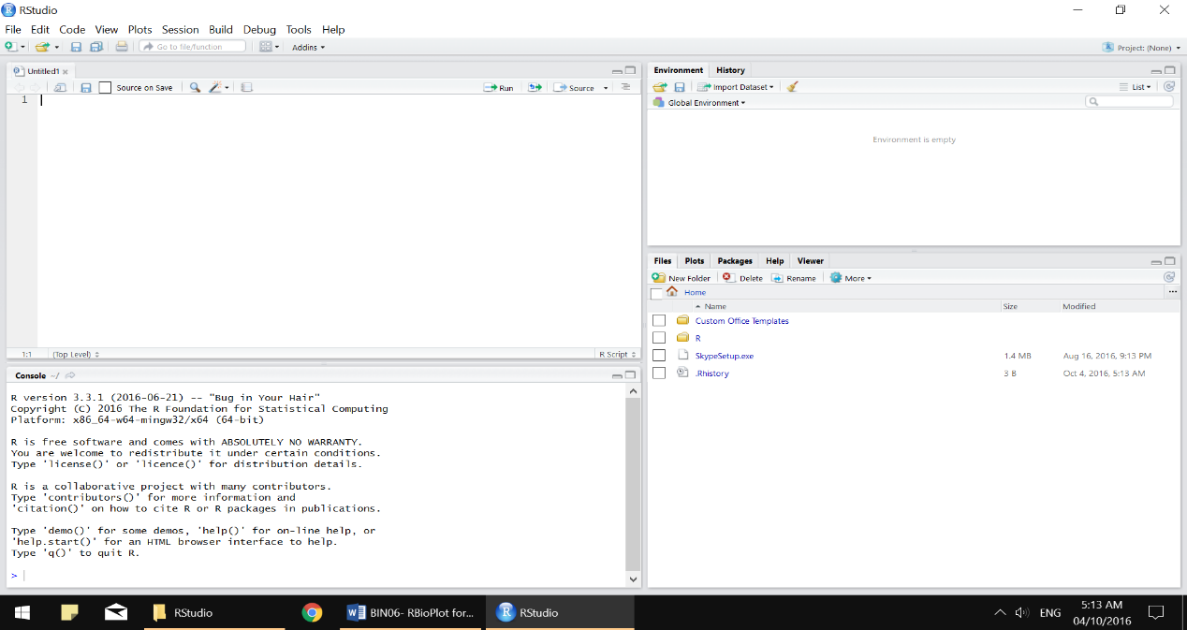
R Script text editor
Environment
Files, Plots, Packages
R Console
!HELP! Home to ALL the RBioplot help pages

1) To setup the R Script text editor go to File New File R Script. The text editor is where you should prepare your R script before running your commands in the console. The text editor also allows you to run multiple commands at the same time (as long as you highlight all the commands you want to run).
2) To use the latest version of RBioplot we need to first install devtools, this package contains some of the various dependencies that RBioplot needs to run. This is a one-time installation, to install ‘devtools’ rewrite the command below in the text editor.
install.packages(“devtools”)

*Note: You must be connected to the internet. You should rewrite all the commands written in this techbull and not just copy them into the text editor. Microsoft word has altered the formatting and syntax of these codes and if you copy/paste this into RStudio, your command will not run as R Script has unique quotation marks. If you copy/paste then make sure you rewrite your quotation marks.
3) To run your R commands, you have two options:
  - R Script text editor, (preferred): Highlight the command you want to run and press Ctrl+Enter. Or place your text cursor on the command you want to run and press Ctrl+Enter. If you separate your command into different lines then make sure all the different commands are highlighted and that they can
  - Console: Copy your command from your text editor to the Console and press Enter.
4) Once your command has been successfully installed you should receive a message that reads something like this:
The downloaded binary packages are in
C:\Users\Hanane\AppData\Local\Temp\Rtmp4gUWDW\downloaded_packages
5) Now you are ready to install the RBioplot package. Run the following command:
devtools::install_github(“jzhangc/git_R_STATS_KBS/package/RBioplot”)

6) You may run into a few errors as the current version of devtools does not contain all the dependencies that RBioplot needs, which means you need to manually install the missing packages.

Here are a few examples of errors and solutions, in this first one I was missing the scales package so I installed it manually:

Error in loadNamespace(i, c(lib.loc, .libPaths()), versionCheck = vI[[i]]) : there is no package called 'scales'
install.packages("scales")

After I installed the missing package (scales) I re-ran the RBioplot installation command in step 5.

Error in loadNamespace(j <- i[[1L]], c(lib.loc, .libPaths()), versionCheck = vI[[j]]) : there is no package called 'sandwich'

Now, I am missing the package (sandwich), so I installed it with the command below and then re-ran the RBioplot installation command from step 5. Repeat this process until you have installed all the missing packages.
install.packages("sandwich")

Once RBioplot has successfully been installed you will get this message:
* DONE (RBioplot)

7) The next step is to setup your working directory, this is where you will place all your input data files and where all your plots, stats, and graphs will be exported to. In this example my working directory file is on my desktop and it’s called “RBioplot stuffs”. To setup your working directory run the following command and replace “C:\Users\Hanane\Desktop” with your folder address:
For Windows: setwd("C:\\Users\\Hanane\\Desktop\\RBioplot stuffs")
For Mac and Linux: setwd("C:\Users\Hanane\Desktop\RBioplot stuffs")

8) In the ‘Files, Plots, and Packages’ quadrant of the graph you should select ‘Packages’ and then find RBioplot in the list. Once you click on RBioplot you will be redirected to a page with the RBioplot documentation and all the help files for the different functions. If you get stuck using one of the commands use these help files to trouble shoot.
9) If your RBioplot stops working or there is an error that you have spent the last 3 weeks troubleshooting, then you should email the developer jzhangcad@gmail.com and beg for help.

III. RBiostats – “that p-value?”
Before starting you should visit the rbiostats help page (or the rbiostats mini-HELP! box on page 5), this will outline all the available functions and how they work. All sample files used and generated can be downloaded from the website. rbiostats is a simple to use function for comprehensive statistical analyses that generates a statistical report for various statistical test including: t-tests, ANOVA, Tukey, and Dunnett. Make sure to read up on the various tests and to ensure you are using the one most appropriate for your data set and experimental design.

1) Your data must be formatted in a very specific manner to ensure the values are analyzed properly by RBioplot. All excel files MUST be saved as a Microsoft Excel Comma Separated Values File (.csv)
Protein Names
Experimental Conditions
2) The table on the right is my Sample Proteins.csv file, standardized western blot relative protein abundances. The values are normalized with coomassie blue loading dye. Experimental conditions are listed in the first column. The A1 cell should read ‘Condition’ – or something similar. Protein names are listed in the first row. The values I report are an average of the relative protein abundance for all my technical replicates that correspond to each of my biological replicates.

*Note: You can analyze and graph your data even with missing outliers in your table.
*Note: Even though I ran 4 different biological replicates for each experimental condition (ie. Control 1, 2, 3, and 4) I have to keep the exact same identifier for each condition or the program will separate them into different conditions.

3) To statistically analyze your data using rbiostats, run the following command and replace “Sample Proteins.csv” with your “file name.csv” and select the stats test you need. (ANOVA is the default)
RBioplot::rbiostats("Sample Proteins.csv", Tp = "ANOVA")
4) As you are typing your command you will notice that RStudio has an auto-fill setting that you will find quite useful. If you hover your mouse over one of the options that appear, you will get a description of the function and the various arguments and customizations available.

7) Outputs a stats.txt file with Shapiro-Wilk normality test results and the results of the statistical analysis of interest, this is automatically exported to your working directory. In this case, my file (on the left) was called Sample Proteins.stats.txt, the complete report can be downloaded from the website. For a detailed break-down of the statistical report refer to Zhang and Storey (2016). Value

rbiostats mini-HELP!

Usage
rbiostats(fileName, Tp = "ANOVA")

Arguments
fileName | Input file name. Case sensitive and be sure to type with quotation marks. Currently only takes .csv files.
Tp | Type of the intended statistical test. Case sensitive and type with quotation marks. Options are: "t-test", "ANOVA", "Tukey" and "Dunnett". Default is "ANOVA".

IV. RBioplot – “that graph?”
After analyzing your statistical report, you can now graph your data. RBioplot allows you to generate Histograms and is excellent for applications such as western blotting, protein abundance levels, transcription factor-DNA binding activity, miRNA expression analyses, mRNA abundance, and many others. All sample files used and generated can be downloaded from the website.
*Note: You will find that the *Notes in this techbull will be useful for all the applications, not just the one it is listed in.

A. Histogram: (rbioplot)
rbioplot is a simple to use function for plotting based on the statistical analysis of choice. Before starting visit the rbioplot help page, this will outline the different functions and arguments and how to properly use them. You can also use the rbioplot mini-HELP! box on page 7.

1) For this example I used the western blotting data set from Sample Proteins.csv (check out rbiostats, step1). The protein abundance, PCR quantification, activity levels, etc. should all be in this format for rbioplot.

2) To generate a histogram run the following rbioplot command:
RBioplot::rbioplot("Sample Proteins.csv", Tp = "Tukey", Title = NULL, errorbar = "SEM", errorbarWidth = 0.2, fontType = "sans", xLabel = NULL, xTickLblSize = 10, xTickItalic = FALSE, xAngle = 0, xAlign = 0.5, yLabel = NULL, yTickLblSize = 10, yTickItalic = FALSE, legendTtl = FALSE, plotWidth = 170, plotHeight = 150, y_custom_tick_range = FALSE, y_lower_limit = 0, y_upper_limit, y_major_tick_range, y_n_minor_ticks = 4)

3) The above command is very versatile and should be tailored to your specific dataset. You can use the customizable arguments to design what your graph looks like. Some of the customizable options include: Type of statistical test, Title, error bars, font, axes labels, Y-axis ticks, and plot height and width. For more information about the individual arguments go to the help pages described above.

4) Once you run the command, a preview of your graph will appear in the lower right quadrant of RStudio. A pdf version of your graph (600 dpi resolution.) will also be automatically exported into your working directory. In this example the pdf generated was titled Sample Proteins.plot.pdf.

*Note: If you re-run the above command using the same input file name then the new generated graph will overwrite your old graph.
*Note: Make sure the .pdf and .plot.pdf file that were generated are closed before re-running. You cannot generate a new file with the exact same name if the old version is active.

5) The above command also outputs a .csv file with detailed metrics for the plot, including Mean, SEM and significance labels. In this sample the exporeted file was named Sample Proteins.plot.csv:

rbioplot mini-HELP!

Usage
rbioplot(fileName, Tp = "Tukey", Title = NULL, errorbar = "SEM",
errorbarWidth = 0.2, fontType = "sans", xLabel = NULL,
xTickLblSize = 10, xTickItalic = FALSE, xAngle = 0, xAlign = 0.5,
yLabel = NULL, yTickLblSize = 10, yTickItalic = FALSE,
legendTtl = FALSE, plotWidth = 170, plotHeight = 150,
y_custom_tick_range = FALSE, y_lower_limit = 0, y_upper_limit,
y_major_tick_range, y_n_minor_ticks = 4)

Arguments
fileName | Input file name. Case sensitive and be sure to type with quotation marks. Currently only takes .csv files.
Tp | Type of the intended statistical test. Case sensitive and be sure to type with quotation marks. Options are: "t-test", "Tukey" and "Dunnett". Default is "Tukey".
Title | The displayed title on top of the plot. Be sure to type with quotation marks. Default is NULL.
errorbar | Set the type of errorbar. Options are standard error of mean ("SEM"), or standard deviation ("SD"). Default is "SEM".
errorbarWidth | Set the width for errorbar. Default is 0.2.
fontType | The type of font in the figure. Default is "sans". For all options please refer to R font table, which is avaiable on the website: http://kenstoreylab.com/?page_id=2448.
xLabel | x axis label. Type with quotation marks. Default is NULL.
xTickLblSize | Font size of x axis ticks. Default is 10.
xTickItalic | Set x axis tick font to italic. Default is FALSE.
xAngle | The rotation angle (degrees) of the x axis marks. Default is 0 - horizontal.
xAlign | The alignment type of the x axis marks. Options are 0, 0.5 and 1. The default value at 0is especially useful when xAngle = 90.
yLabel | y axis label. Type with quotation marks. Default is NULL.
yTickLblSize | Font size of y axis ticks. Default is 10.
yTickItalic | Set y axis tick font to italic. Default is FALSE.
legendTtl | Hide/Display legend title. If TRUE or T, the name of the first column of the raw data file will display as the legend title. Default is FALSE.
plotWidth | The width of the plot (unit: mm). Default is 170. Default will fit most of the cases.
plotHeight | The height of the plot (unit: mm). Default is 150. Default will fit most of the cases.
y_custom_tick_range | To initiate setting the custom y_upper_limit, y_lower_limit,y_major_tick_range, y_n_minor_ticks. Default is FALSE.
y_lower_limit | Can only be set when y_custom_tick_range = TRUE. Set custom lower limt for y axis. Default is 0. Value can be obtained from autorange_bar_y.
y_upper_limit | Can only be set when y_custom_tick_range = TRUE. Set custom upper limt for y axis. Value can be obtained from autorange_bar_y.
y_major_tick_range | Can only be set when y_custom_tick_range = TRUE. Set custom major tick range for y axis. Value can be obtained from autorange_bar_y.
y_n_minor_ticks | Can only be set when y_custom_tick_range = TRUE. Set custom numbers of minor ticks. Default is 4. Value can be obtained from autorange_bar_y.

B. Heatmap: (rbioplot_heatmap)
The rbioplot_heatmap function can be used to analyze and graph largescale high-throughput studies such as large explorations of microRNA differential expression. rbioplot_heatmap is a function for plotting simple heatmaps based on the statistical analysis of your choice. Before starting visit the rbioplot_heatmap help page, this will outline the different functions and arguments and how to properly use them. You can also use the rbioplot_heatmap mini-HELP! box on page 10, for a quick reference.

1) The table below is my Sample miRNAs.csv file, the values are standardized miRNA relative abundance levels (obtained from qRT-PCR and normalized to the reference gene). The A1 cell should contain the word microRNA (or whatever you are measuring). The values I report are an average of the relative miRNA abundance for all my technical replicates that correspond to each of my biological replicates. This is just a small portion of the file- the full file contains 152 microRNAs.

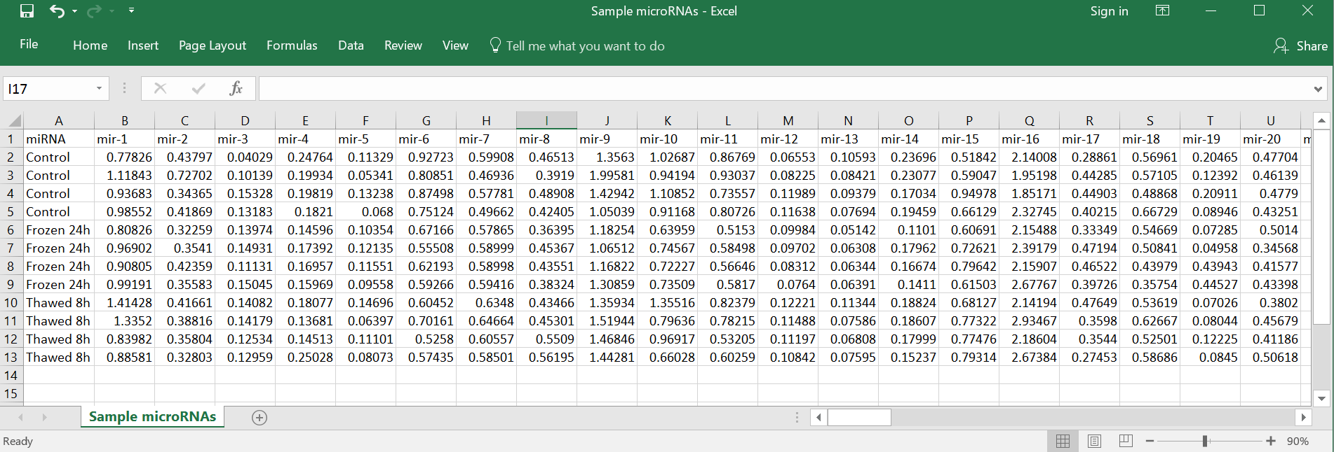

2) To generate a heatmap run the following rbioplot command:
RBioplot::rbioplot_heatmap("Sample microRNAs.csv", Tp = "Dunnett", rmCntl = FALSE, Title = NULL, fontType = "sans", tileLow = "firebrick1", tileHigh = "green2", tileLbl = TRUE, tileLblSize = 5, tileTxtColour = "white", tileLblPos = 0.5, xLabel = NULL, xTickLblSize = 10, xTickItalic = FALSE, xAngle = 0, xAlign = 0.5, yLabel = NULL, yTickLblSize = 10, yTickItalic = FALSE, legendTtl = FALSE, legendPos = "right", plotWidth = 170, plotHeight = 600)

3) The above command is very versatile and should be tailored to your specific dataset. You can also easily change the colour scheme of your heatmap, refer to V. RBioplot Resources for the full colour palette available on with R. For more information on how to customize the arguments go to the help page or the mini-help box.

4) The above rbioplot_heatmap command outputs a .plot.csv file with detailed metrics for the plot, including normalized mean and significance labels, as well as a plot image file (.pdf), with 600 dpi resolution.
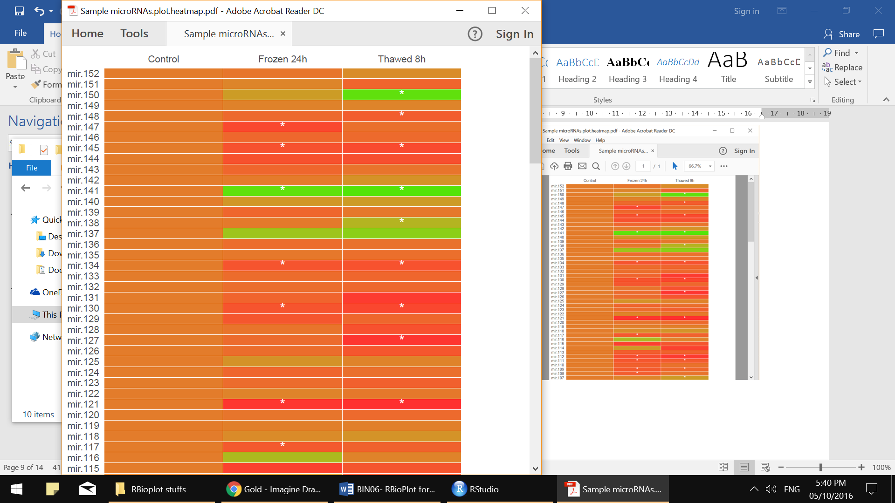

rbioplot_heatmap mini-HELP!

Usage
rbioplot_heatmap(fileName, Tp = "Dunnett", rmCntl = FALSE, Title = NULL,
fontType = "sans", tileLow = "skyblue", tileHigh = "midnightblue",
tileLbl = TRUE, tileLblSize = 10, tileTxtColour = "white",
tileLblPos = 0.5, xLabel = NULL, xTickLblSize = 10,
xTickItalic = FALSE, xAngle = 0, xAlign = 0.5, yLabel = NULL,
yTickLblSize = 10, yTickItalic = FALSE, legendTtl = FALSE,
legendPos = "bottom", plotWidth = 170, plotHeight = 150)

Arguments
fileName | Input file name. Case sensitive and be sure to type with quotation marks. Currently only takes .csv files.
Tp | Type of the intended statistical test. Case sensitive and be sure to type with quotation marks. Options are: "t-test", "Tukey" and "Dunnett". Default is "Dunnett".
rmCntl | Remove the first column (i.e., control). Default is FALSE.
Title | The displayed title on top of the plot. Be sure to type with quotation marks. Default is NULL.
fontType | The type of font in the figure. Default is "sans". For all options please refer to R font table, which is avaiable on the website:http://kenstoreylab.com/?page_id=2448.
tileLow | Set the colour for the lower limit of the heatmap. Default is skyblue. For full colour options and names, refer to the websitehttp://kenstoreylab.com/?page_id=2448.
tileHigh | Set the colour for the upper limit of the heatmap. Default ismidnightblue. For full colour options and names, refer to the website http://kenstoreylab.com/?page_id=2448.
tileLbl | Enable or disable significant notation on the tiles. Default is TRUE.
tileLblSize | Set the font size of the tile label. Default is 10.
tileTxtColour | Set the colour of the on tile label. Default is "white". For full colour options and names, refer to the website http://kenstoreylab.com/?page_id=2448.
tileLblPos | Set the position of the tile lables. Options are 0, 0.5 and 1. Default is 0.5.
xLabel | x axis label. Type with quotation marks. Default is NULL.
xTickLblSize | Font size of x axis ticks. Default is 10.
xTickItalic | Set x axis tick font to italic. Default is FALSE.
xAngle | The rotation angle (degrees) of the x axis marks. Default is 0 - horizontal.
xAlign | The alignment type of the x axis marks. Options are 0, 0.5 and 1. The default value at 0 is especially useful when xAngle = 90.
yLabel | y axis label. Type with quotation marks. Default is NULL.
yTickLblSize | Font size of y axis ticks. Default is 10.
yTickItalic | Set y axis tick font to italic. Default is FALSE.
legendTtl | Hide/Display legend title. Default is FALSE.
legendPos | Set the legend position. Options are "top", "bottom", "left"and "right". Default is "bottom".
plotWidth | The width of the plot (unit: mm). Default is 170. Default will fit most of the cases.
plotHeight | The height of the plot (unit: mm). Default is 150. Default will fit most of the cases.
y_custom_tick_range | To initiate setting the custom y_upper_limit, y_lower_limit,y_major_tick_range, y_n_minor_ticks. Default is FALSE.
y_upper_limit | Can only be set when y_custom_tick_range = TRUE. Set custom upper limt for y axis. Value can be obtained fromautorange_bar_y.
y_lower_limit | Can only be set when y_custom_tick_range = TRUE. Set custom lower limt for y axis. Default is 0. Value can be obtained fromautorange_bar_y.
y_major_tick_range | Can only be set when y_custom_tick_range = TRUE. Set custom major tick range for y axis. Value can be obtained fromautorange_bar_y.
y_n_minor_ticks | Can only be set when y_custom_tick_range = TRUE. Set custom numbers of minor ticks. Default is 4. Value can be obtained from autorange_bar_y.

C. Joint-point curve: (rbioplot_curve)
rbioplot_curve is a simple to use function for plotting joining-point curve figures with continuous X-axis and Y-axis values. Before starting visit the rbioplot_curve help page, this will outline the different functions and arguments and how to properly use them. You can also use the rbioplot_curve mini-HELP! box on page 12.

1) In this example below I plotted my imaginary enzyme’s activity for 18 eluted fractions from both control and 24 h frozen. I used the Sample Elution Profile.csv (below). The independent variables are listed in column A.

2) To generate a histogram run the following rbioplot command:
RBioplot::rbioplot_curve("Sample Elution Profile.csv", Title = NULL, errorbar = "SEM", errorbarWidth = 0.2, fontType = "sans", symbolSize = 2, xLabel = "Fraction", xTickLblSize = 10, xTickItalic = FALSE, xAngle = 0, xAlign = 0.5, yLabel = "Relative Activity", yTickLblSize = 10, yTickItalic = FALSE, legendTtl = FALSE, plotWidth = 170, plotHeight = 150, x_custom_tick_range = TRUE, x_lower_limit = 5, x_upper_limit = 23, x_major_tick_range = 1, x_n_minor_ticks = 0, y_custom_tick_range = TRUE, y_lower_limit = -0.2, y_upper_limit = 1.2, y_major_tick_range = 0.2, y_n_minor_ticks = 4)

3) The above rbioplot_curve command outputs a .plot.csv file with detailed metrics for the plot, including Mean and SEM, as well as a plot image file (.pdf), with 600 dpi resolution.
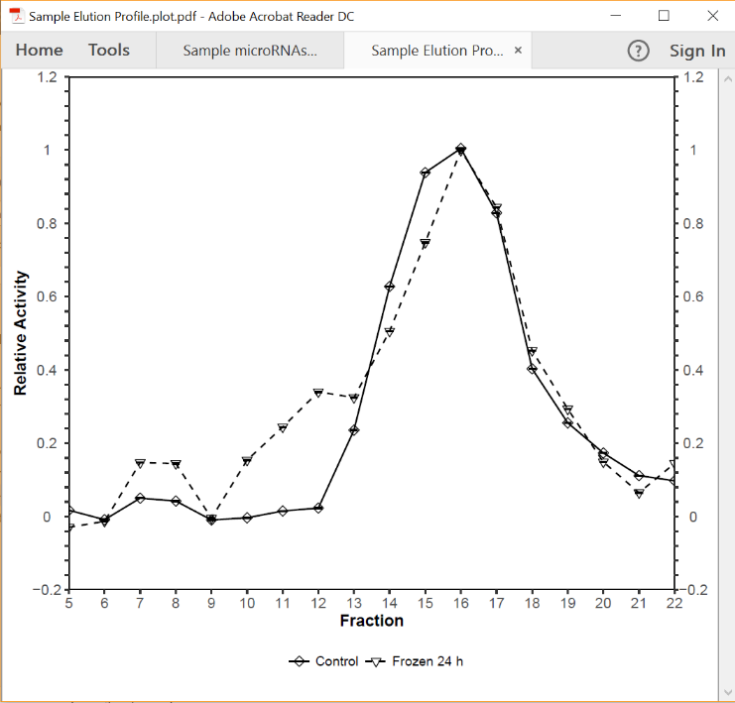

rbioplot_curve mini-HELP!

Usage
rbioplot_curve(fileName, Title = NULL, errorbar = "SEM",
errorbarWidth = 0.2, fontType = "sans", symbolSize = 2, xLabel = NULL,
xTickLblSize = 10, xTickItalic = FALSE, xAngle = 0, xAlign = 0.5,
yLabel = NULL, yTickLblSize = 10, yTickItalic = FALSE,
legendTtl = FALSE, plotWidth = 170, plotHeight = 150,
x_custom_tick_range = FALSE, x_lower_limit = 0, x_upper_limit,
x_major_tick_range, x_n_minor_ticks = 0, y_custom_tick_range = FALSE,
y_lower_limit = 0, y_upper_limit, y_major_tick_range, y_n_minor_ticks = 4)

Arguments
fileName | Input file name. Case sensitive and be sure to type with quotation marks. Currently only takes .csv files. Note that the column names (excluding the first column) need to be numeric.
Title | The displayed title on top of the plot. Be sure to type with quotation marks. Default is NULL.
errorbar | Set the type of errorbar. Options are standard error of mean ("SEM"), or standard deviation ("SD"). Default is "SEM".
errorbarWidth | Set the width for errorbar. Default is 0.2.
fontType | The type of font in the figure. Default is "sans". For all options please refer to R font table, which is avaiable on the website:http://kenstoreylab.com/?page_id=2448.
symbolSize | Set the size of symbols. Default is 2.
xLabel | x axis label. Type with quotation marks. Default is NULL.
xTickLblSize | Font size of x axis ticks. Default is 10.
xTickItalic | Set x axis tick font to italic. Default is FALSE.
xAngle | The rotation angle (degrees) of the x axis marks. Default is 0 - horizontal.
xAlign | The alignment type of the x axis marks. Options are 0, 0.5 and 1. The default value at 0 is especially useful when xAngle = 90.
yLabel | y axis label. Type with quotation marks. Default is NULL.
yTickLblSize | Font size of y axis ticks. Default is 10.
yTickItalic | Set y axis tick font to italic. Default is FALSE.
legendTtl | Hide/Display legend title. If TRUE or T, the name of the first column of the raw data file will display as the legend title. Default is FALSE.
plotWidth | The width of the plot (unit: mm). Default is 170. Default will fit most of the cases.
plotHeight | The height of the plot (unit: mm). Default is 150. Default will fit most of the cases.
x_custom_tick_range | To initiate setting the custom x_upper_limit, x_lower_limit,x_major_tick_range, x_n_minor_ticks. Default is FALSE.
x_lower_limit | Can only be set when x_custom_tick_range = TRUE. Set custom lower limt for x axis. Default is 0. Value can be obtained fromautorange_curve.
x_upper_limit | Can only be set when x_custom_tick_range = TRUE. Set custom upper limt for x axis. Value can be obtained fromautorange_curve.
x_major_tick_range | Can only be set when x_custom_tick_range = TRUE. Set custom major tick range for x axis. Value can be obtained fromautorange_curve.
x_n_minor_ticks | Can only be set when x_custom_tick_range = TRUE. Set custom numbers of minor ticks. Default is 4. Value can be obtained from autorange_curve.
y_custom_tick_range | To initiate setting the custom y_upper_limit, y_lower_limit,y_major_tick_range, y_n_minor_ticks. Default is FALSE.
y_lower_limit | Can only be set when y_custom_tick_range = TRUE. Set custom lower limt for y axis. Default is 0. Value can be obtained fromautorange_curve.
y_upper_limit | Can only be set when y_custom_tick_range = TRUE. Set custom upper limt for y axis. Value can be obtained from autorange_curve.
y_major_tick_range | Can only be set when y_custom_tick_range = TRUE. Set custom major tick range for y axis. Value can be obtained fromautorange_curve.
y_n_minor_ticks | Can only be set when y_custom_tick_range = TRUE. Set custom numbers of minor ticks. Default is 4. Value can be obtained from autorange_curve.

V. RBioplot Resources
To customize your graphs and make them more visually appealing (or usually you have to make them more boring for journals), you can refer to the R colour palette and R font table below.
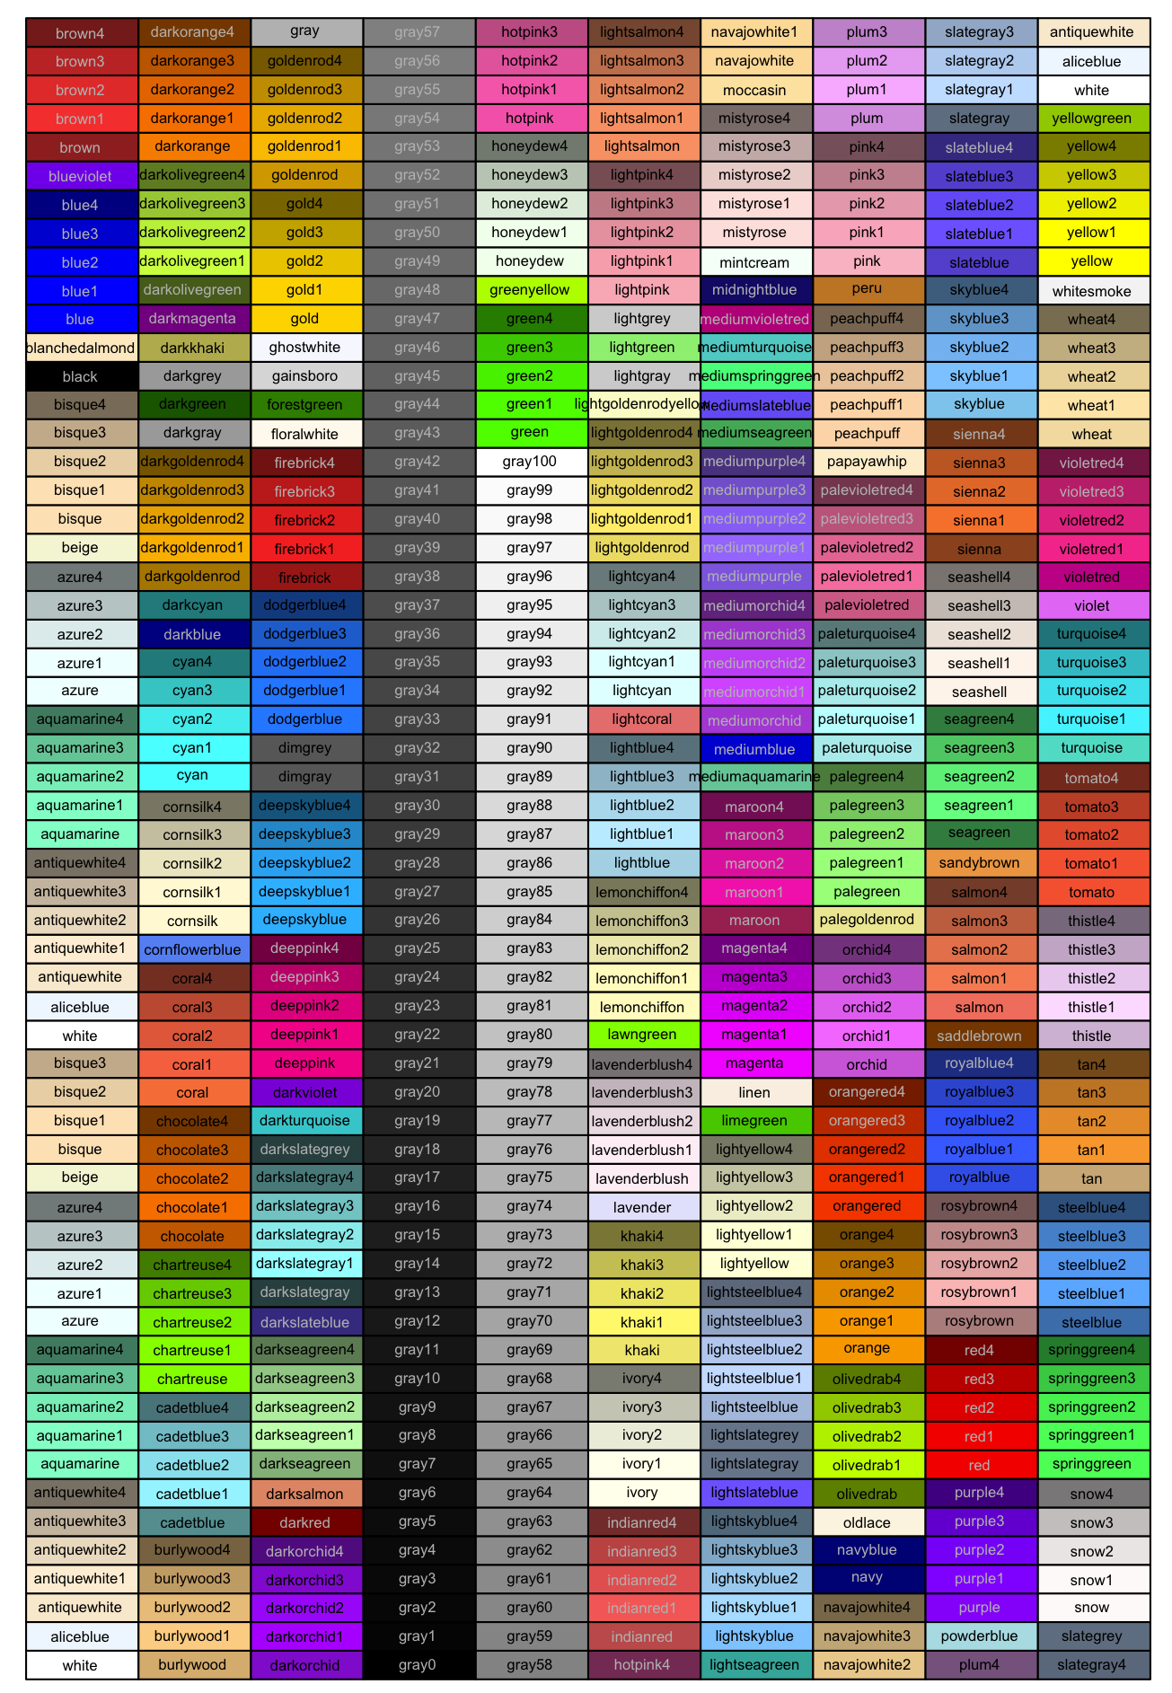
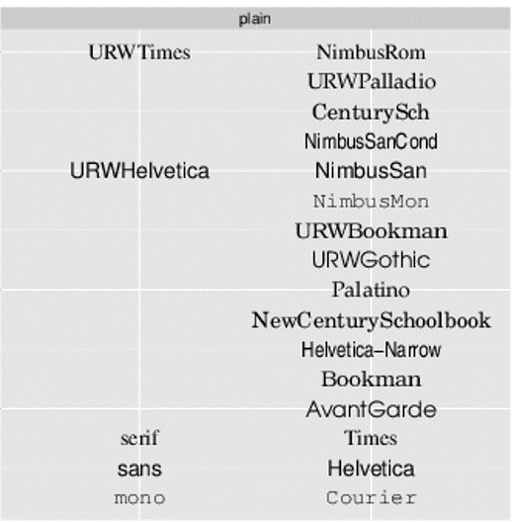
R colour palette R font table

